**Mauritius country profile**

Published

30 June

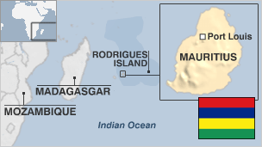

**Mauritius is a stable and prosperous Indian Ocean archipelago.**

Once dependent on sugar exports, the island has built up a strong outsourcing and financial services sector, as well as an important tourism industry, and now boasts one of Africa's highest per capita incomes.

Mauritius claims sovereignty over the Chagos Islands, in a dispute with Britain that saw hundreds of islanders deported to make way for a US military base on the island of Diego Garcia in the 1960s.

* Read more [country profiles](http://news.bbc.co.uk/1/hi/country_profiles/) - Profiles by [BBC Monitoring](http://bbc.co.uk/monitoring)

**President: Prithvirajsing Roopun**

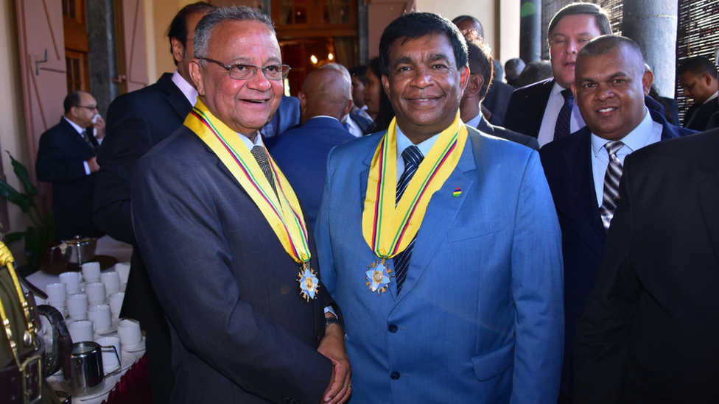image copyrightGetty Images

image captionPresident Prithvirajsing Roopun (right)

Arts and Culture Minister Prithvirajsing "Pradeep" Roopun was elected to the largely ceremonial post of president in December 2019.

**Prime minister: Pravind Kumar Jugnauth**

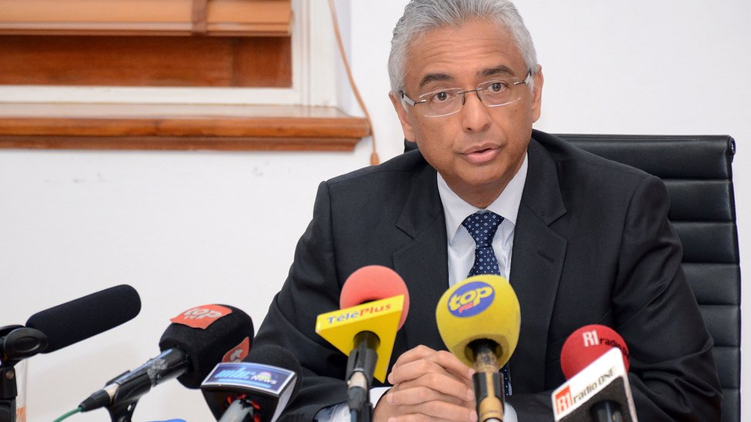image copyrightGetty Images

Pravind Kumar Jugnauth succeeded his father, Sir Anerood Jugnauth, as prime minister in January 2017.

Until he stepped down, Sir Anerood had been the longest-serving prime minister since Mauritius gained independence from Britain in 1968.

Mr Jugnauth is leader of the Militant Socialist Movement party.

State-owned Mauritius Broadcasting Corporation (MBC) radio and TV generally reflect government thinking. MBC is funded by advertising and a TV licence fee.

Television is the most popular medium.

# Mauritius profile - Timeline

Published

25 February 2019

## A chronology of key events:

**10th century** - Phoenicians, Malays, Swahili and Arab seamen visit island but do not settle.

**1510** - Portuguese navigator Pedro Mascarenhas visits the island and names it Cirné. It is used as a port of call, but the Portuguese do not establish a permanent settlement.

## Early settlement

**1598** - Dutch claim the uninhabited island and rename it after their head of state, Maurice, Prince of Orange and Count of Nassau.

**1664-1710** - Dutch withdraw after repeated attempts at colonisation. By this time the dodo - a unique bird found only on Mauritius - has become extinct.

**1715** - French East India Company claims Mauritius for France.

**1796** - Settlers break away from French control when the government in Paris attempts to abolish slavery.

**1810** - British forces land in Mauritius after defeating the French in battle at Cap Malheureux.

## British rule

**1814** - Mauritius, Seychelles and Rodrigues ceded to Britain under Treaty of Paris.

**1834** - British abolish slavery.

**1835** - Indentured labour system introduced. In subsequent decades hundreds of thousands of workers arrive from India.

**1926** - First Indo-Mauritians elected to government council.

## Self-government

**1942** - Donald Mackenzie-Kennedy becomes governor. Introduces consultative committee, which for the first time includes representatives from all Mauritian communities.

**1957** - Internal self-government introduced, with an electoral system based on the Westminster model.

**1959** - First elections under universal adult suffrage won by Labour Party of Seewoosagur Ramgoolam.

**1960** - Cyclone Carol devastates island, leaving thousands homeless and prompting a housing revolution.

**1966** - Britain expels some 2,000 residents of the Chagos archipelago, many to Mauritius, and leases islands to the US for 50 years. US builds a military base on the largest island, Diego Garcia.

## Independence

**1968** - 12 March - Independence.

**1969** - Opposition Mauritian Militant Movement (MMM) founded, advocates socialism, led by Paul Berenger.

**1971** - First Export Processing Zone created. Textiles sector develops. Between 1971-77, 64,000 jobs are created.

**1971** - MMM, backed by unions, calls a series of strikes. State of emergency declared, lasts until 1976. MMM party's leadership imprisoned.

**1982** - Sir Anerood Jugnauth becomes prime minister.

## Republic

**1992** March - Prime Minister Jugnauth declares Mauritius a republic.

**1995** December - Labour Party leader Navin Ramgoolam becomes prime minister.

**1999** February - Creole singer Kaya dies in police custody, prompting four days of rioting among Creole community.

**2000** - September - Militant Socialist Movement leader Sir Anerood Jugnauth returns as prime minister.

**2002** February - Cassam Uteem resigns as president, refusing to sign controversial anti-terrorism bill. Vice president also refuses to sign and resigns. Head of legislature becomes acting president and passes legislation into law.

**2002** - "Cyber Cities" plan launched to create concentrations of hi-tech facilities and boost economy.

**2005** July - Labour Party returns to power under Navin Ramgoolam.

**2008** - British House of Lords upholds government appeal against 2000 High Court court ruling that families expelled from the Chagos Islands are entitled to return home.

**2010** June - Mauritius, France agree to jointly manage Tromelin, a tiny Indian Ocean island owned by France but claimed by Mauritius.

## Chagos dispute

**2012** December - European Court of Human Rights rejects claim by Chagos Islanders against Britain over their expulsion.

**2014** December - Opposition alliance led by ex-President Anerood Jugnauth wins a landslide victory in parliamentary elections.

**2018** March - President Ameenah Gurib steps down over an expenses scandal.

**2019** February - The UN International Court of Justice says Britain should end its control over the Chagos Islands as soon as possible, in a non-binding legal opinion that they were not lawfully separated from Mauritius in 1965.

**2019** November - Pravind Kumar Jugnauth, who succeeded his father Sir Anerood Jugnauth, as prime minister in January 2017, wins the general election for the centre-left Militant Socialist Movement.